|  |  |  |
| --- | --- | --- |
|  | **LICEO SAMARIO SCHOOL**  **REINFORCEMENT PLAN** | CÓDIGO: LS-PT02-22 |
| VERSIÓN: 05 |
| APROBO  RECTOR | PÁGINA : 1 |
| VIGENCIA : 30/11/2017 |

**STUDENT NAME: _____________________________________________ GRADE: FOURTH _______**

**SUBJECT ______ENGLISH_____ TEACHER** **WALTER ARIAS ALDANA TERM _____FIRST________**

* DELIVER DATE BY TEACHER TO THE STUDENT _______________________________
* DELIVER DATE BY STUDENT _______________________________
* TEST DATE _______________________________

**CRITERIA TO ELABORATE THE PLAN: TOOLS SUPPORT:**

* Hand writing -Homework Notebook
* The plan must be completed totally - Web page
* To deliver the plan punctually - Blog
* To support it. - Books

**SUGGESTED METHODOLOGY EVALUATION CRITERIA**

* Texts analysis - 10 points (Plan presentation)
* Graphs analysis - 40 Points (Test)
* Maps Analysis
* Others

[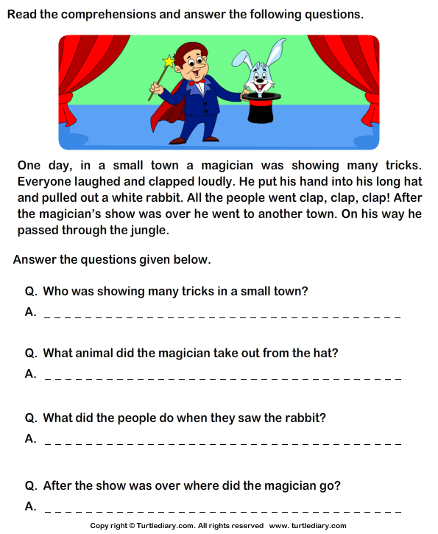](https://www.google.com/url?sa=i%26url=https://www.turtlediary.com/worksheet/reading-comprehension-magician.html%26psig=AOvVaw3R_3ELcr-RmnrGQcD-2lEd%26ust=1581473394264000%26source=images%26cd=vfe%26ved=0CAIQjRxqFwoTCLCR4dm1yOcCFQAAAAAdAAAAABAp)

Complete using Be going to.

[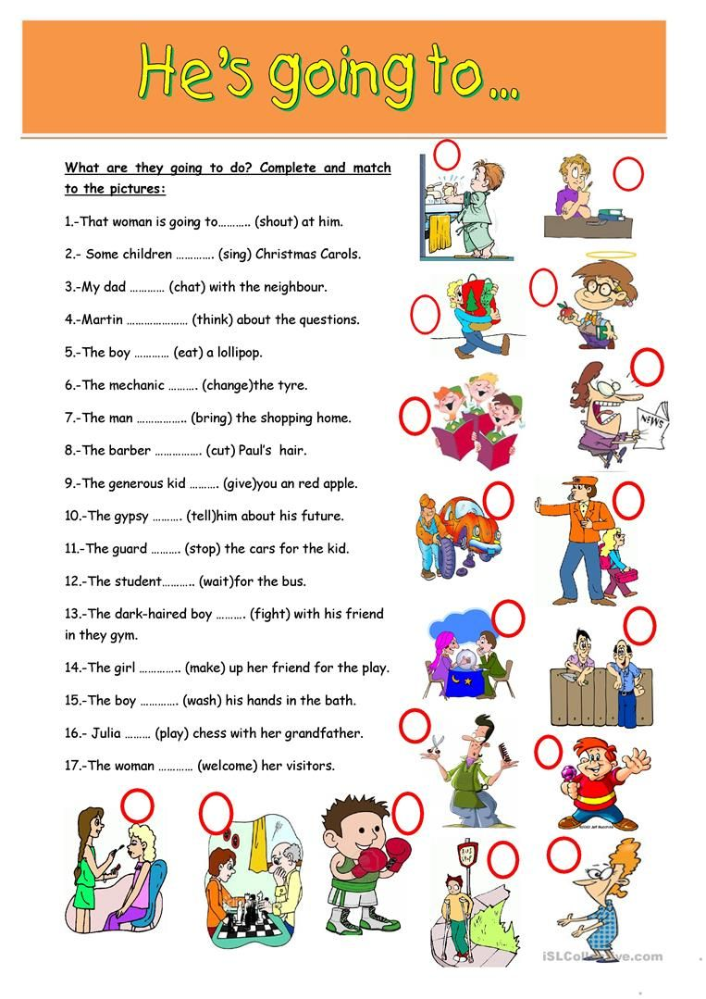](https://www.google.com/url?sa=i%26url=https://www.pinterest.com/pin/113012271883728958/%26psig=AOvVaw0gPAcIKvt_sTYPJl1_3wYR%26ust=1581476202757000%26source=images%26cd=vfe%26ved=0CAIQjRxqFwoTCPDzoKDAyOcCFQAAAAAdAAAAABAK)

[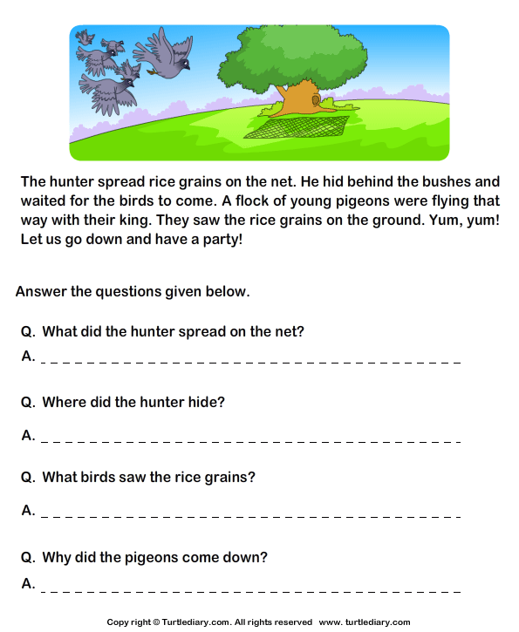](https://www.google.com/url?sa=i%26url=https://www.turtlediary.com/worksheet/reading-comprehension-hunter-and-pigeons.html%26psig=AOvVaw3R_3ELcr-RmnrGQcD-2lEd%26ust=1581473394264000%26source=images%26cd=vfe%26ved=0CAIQjRxqFwoTCLCR4dm1yOcCFQAAAAAdAAAAABA_)

[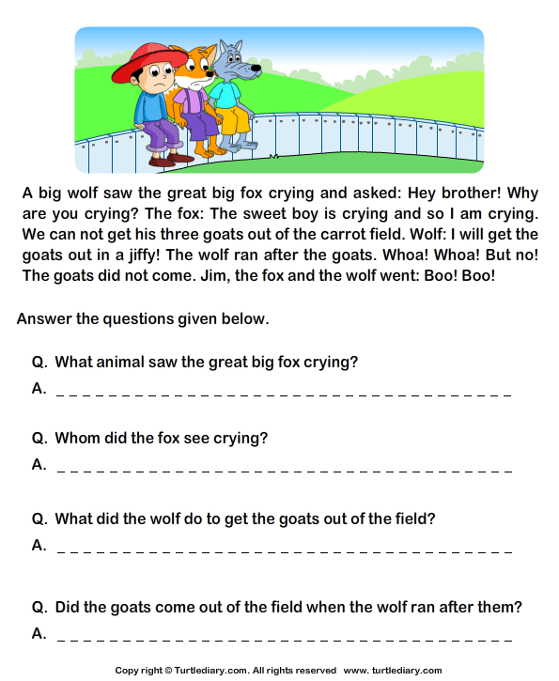](https://www.google.com/url?sa=i%26url=https://www.pinterest.co.uk/pin/658510776735740797/%26psig=AOvVaw3R_3ELcr-RmnrGQcD-2lEd%26ust=1581473394264000%26source=images%26cd=vfe%26ved=0CAIQjRxqFwoTCLCR4dm1yOcCFQAAAAAdAAAAABAu)

Match the exercises.

[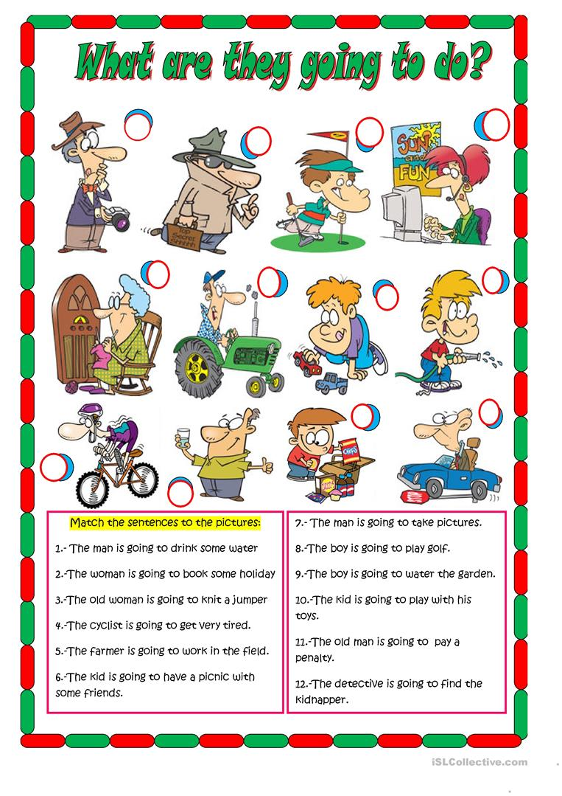](https://www.google.com/url?sa=i%26url=https://en.islcollective.com/english-esl-worksheets/grammar/future-tenses/what-are-they-going-do/63678%26psig=AOvVaw3W28aejmfGnnEXySACoPZI%26ust=1581476914250000%26source=images%26cd=vfe%26ved=0CAIQjRxqFwoTCNDB6eXCyOcCFQAAAAAdAAAAABAQ)